RTL CHALLENGE

DAY-8:- Verilog Code for Implementation of Multiplexer

Software used:- Xilinx Vivado(2023.1)
Theory:
A multiplexer, commonly referred to as a "mux," is a crucial component in digital circuitry, facilitating the selection and routing of multiple input signals to a single output line. Its operation is governed by control signals that dictate which input line is chosen for transmission. With multiple input channels and one output line, the multiplexer efficiently consolidates data streams, enabling streamlined data processing and
transmission within digital systems. Whether in telecommunications, data compression, or memory systems, multiplexers play a pivotal role in optimizing resource utilization and enhancing the efficiency of
digital operations. By selectively directing signals, multiplexers contribute to the complexity and functionality of modern electronic devices, serving as foundational elements in their design and operation

Block Diagram:
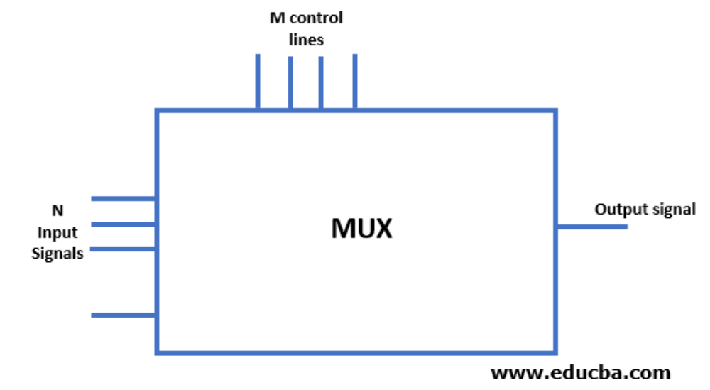

Design Codes for Multiplexer:-
2 * 1 Multiplexer Design Code:

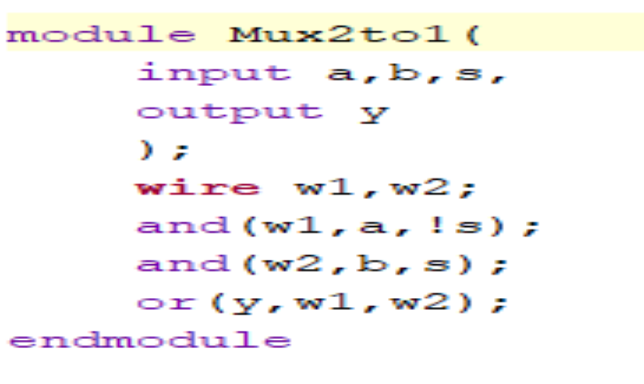
TEST BENCH:
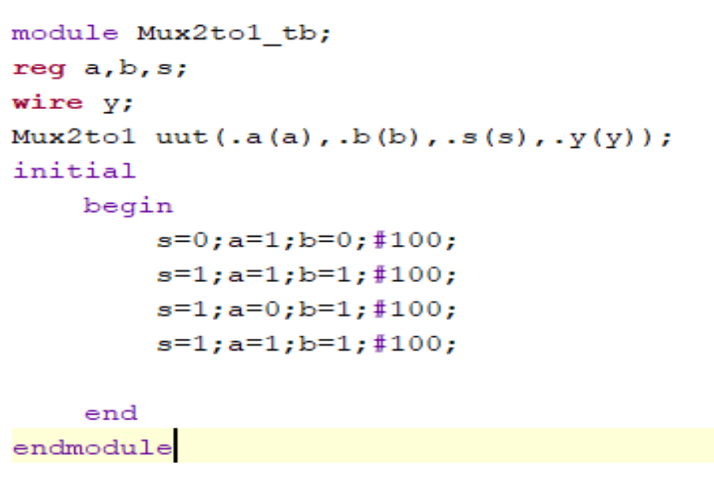
Schematic:-
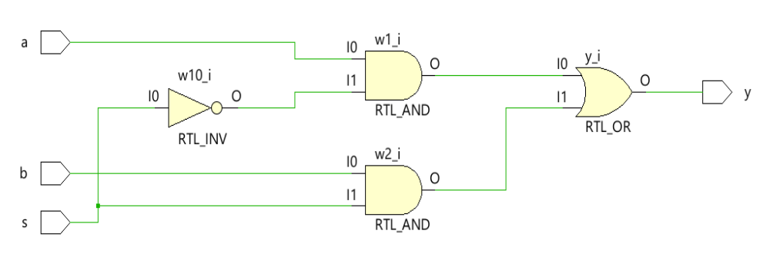
OutPut WaveForms:-

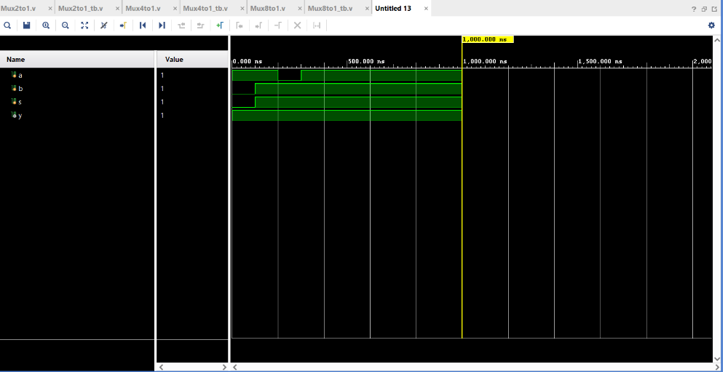
Code for 4 to 1 mux :-
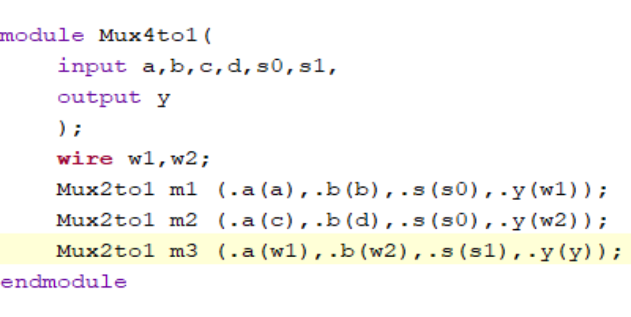

Test Bench :-

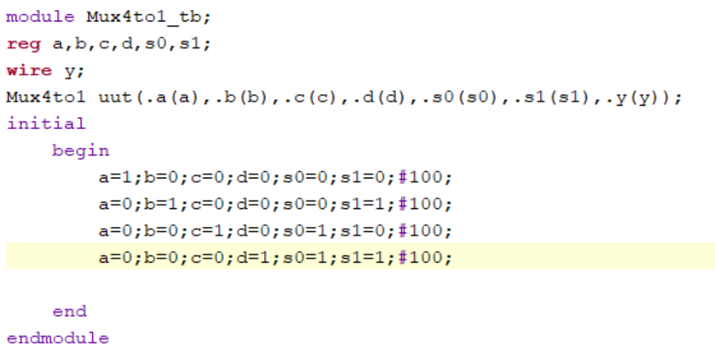

Schematic:-

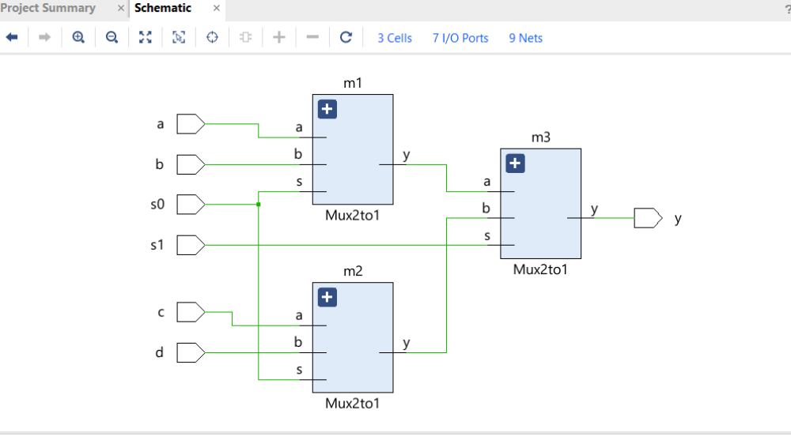

Output Waveforms:-

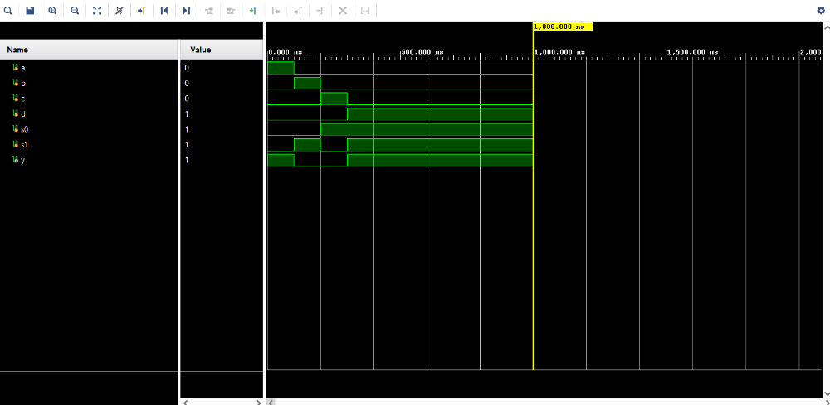

Code for Mux 8 to 1:

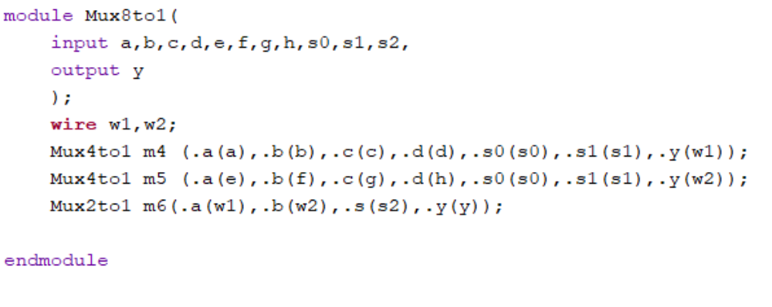

Test Bench:-

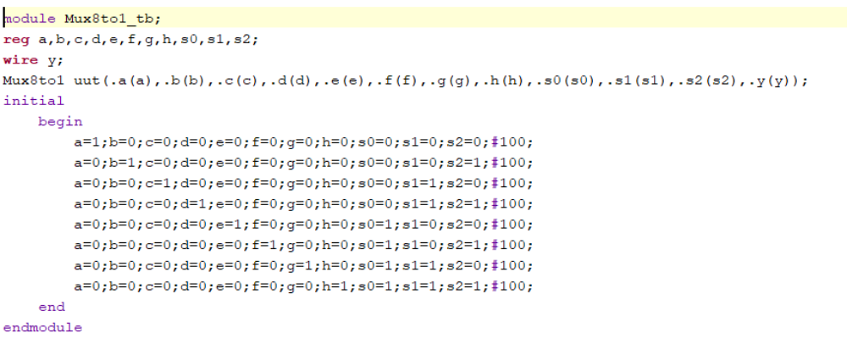

Schematic:-
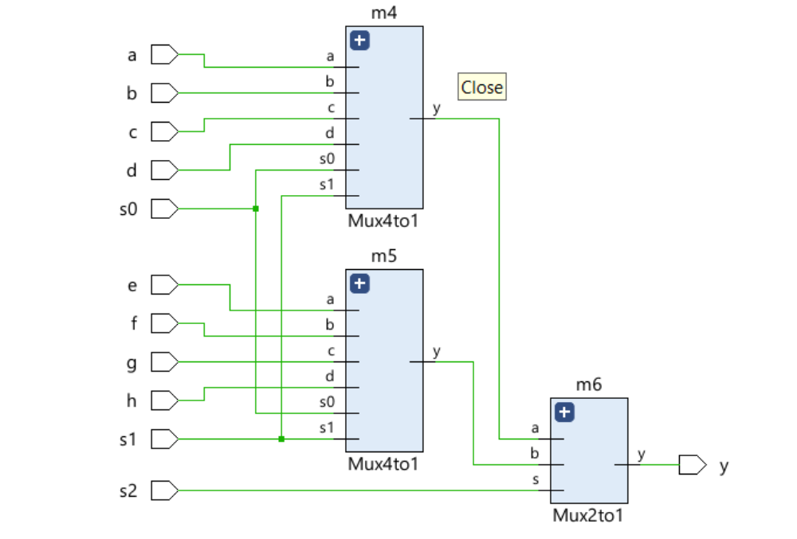

Output Waveforms:-

